Tech Talk Presentation: Russell Hinderman
iPad Pro Models: A Tech Talk by Russell Hinderman

Slide 1: iPad Pro, One Name, Many Models
- Apple's most powerful tablet line
- Made by Apple since 2015
- iPadOS 27 arrived September 14, 2026
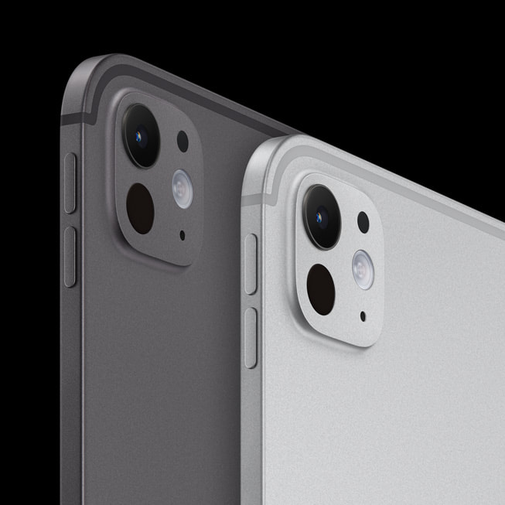

Speaker Notes
The first-ever iPad Pro was released in 2015. It had the A9X chip and ran iOS 9.1.

Slide 2: 12.9-inch iPad Pro, Sixth Generation
- Released October 2022
- M2 chip, mini-LED display
- Apple Pencil hover


Speaker Notes
The 12.9-inch iPad Pro, sixth generation, is perfect for creators. It can handle demanding tasks like running digital audio workstations (DAWs) and video editing.

Slide 3: 13-inch iPad Pro with M4
- Released May 2024
- Tandem OLED display
- Only 5.1 millimeters thin


Speaker Notes
The iPad Pro with M4 is perfect for extremely demanding tasks like 3D rendering. These powerhouses can do many things that a Mac computer can.

Slide 4: 13-inch iPad Pro with M5
- Released October 2025
- Much faster AI
- Wi-Fi 7, faster charging
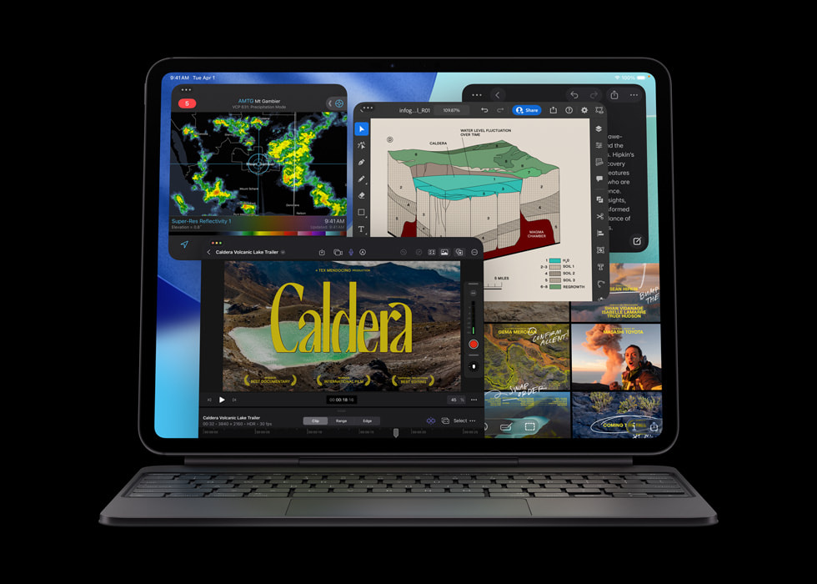

Speaker Notes
This iPad is perfect for on-device AI workflows, like running AI models on the device itself. This beast performs very well on complex tasks.

Slide 5: Why It Matters
- Students, artists, and video editors
- Benefit: laptop power, tablet size
- Next model rumored for 2027
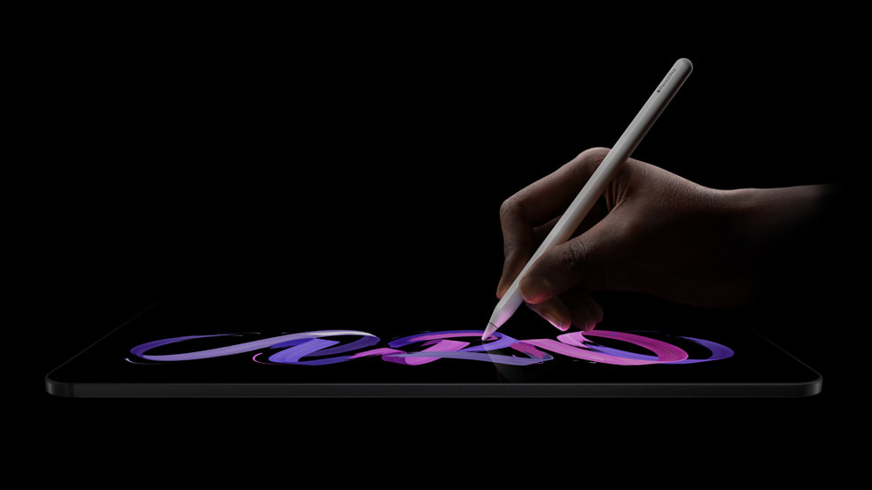
Source: MacRumors, September 2026

Speaker Notes
iPads in general are useful for artists, video editors, and music producers. These devices will keep getting more powerful with every software and hardware update.

Sources
- Apple Support: iPad Pro 12.9-inch (6th generation) Technical Specifications
Link: https://support.apple.com/en-us/111841
- Apple Newsroom, October 18, 2022: Apple introduces next-generation iPad Pro, supercharged by the M2 chip
Link: https://www.apple.com/newsroom/2022/10/apple-introduces-next-generation-ipad-pro-supercharged-by-the-m2-chip/
- Apple Newsroom, May 7, 2024: Apple unveils stunning new iPad Pro with M4 chip and Apple Pencil Pro
Link: https://www.apple.com/newsroom/2024/05/apple-unveils-stunning-new-ipad-pro-with-m4-chip-and-apple-pencil-pro/
- Apple Newsroom, October 15, 2025: Apple introduces the powerful new iPad Pro with the M5 chip
Link: https://www.apple.com/newsroom/2025/10/apple-introduces-the-powerful-new-ipad-pro-with-the-m5-chip/
- Apple Support: Identify your iPad model
Link: https://support.apple.com/en-us/108043
- MacRumors: iPadOS 27: Everything We Know
Link: https://www.macrumors.com/roundup/ipados-27/
- iClarified, June 9, 2026: iPadOS 27 Supported Devices: Full List of Compatible iPads
Link: https://www.iclarified.com/101128/ipados-27-supported-devices-full-list-of-compatible-ipads
- PhoneArena: Don't expect a new iPad Pro this year, or a major redesign from the 2027 generation
Link: https://www.phonearena.com/news/apple-no-new-ipad-pro-edition-2026-no-major-redesign-2027-generation_id181557

Image Credits
All slide images are from Apple Newsroom (sources 2, 3, and 4).
Slide 1: The backs of two iPad Pro models with M5, one space black and one silver, showing the rear cameras.
Slide 2: The 2022 iPad Pro in 12.9-inch and 11-inch sizes side by side, with colorful wallpaper on the screens.
Slide 3: The 13-inch iPad Pro with M4 seen edge-on from the side. It looks like a thin line.
Slide 4: The iPad Pro with M5 attached to a Magic Keyboard, with several apps open on the screen.
Slide 5: A hand drawing on the iPad Pro with M5 using an Apple Pencil Pro.

